ADD YOUR ADDRESS HERE
94254-001 UK.BE14

ADD YOUR P ATIENT’S AD DRESS HERE

Date

Dear ADD YOU R PATIE N T’S NAME HERE ,

Your vision is a precious thing, and we at ADD YOUR NAME HERE are dedicated to protecting it, so that you can maintain a mobile, independent and enjoyable life.

We are contacting you as one of our Cataract patients to let you know about a new imaging technology that will allow us to see through your cataract. One in two sixty year olds has some form of cataract. A developing cataract can mask any underlying problems within the retina, making it difficult to diagnose other sight threatening conditions like Age-Related Macular Degenerations or Glaucoma.

A comprehensive eye health check can reveal early changes in your eyes of which you may be unaware. Early detection allows for early treatment and a better outcome for you. With our new 4D HD imaging technology, we are now able to identify eye diseases, even through developing cataracts and monitor the smallest change and that changes everything.

The SPECTRALIS 4D HD Eye Health Check, uses a patented eye-tracking system that produces 3-dimensional images of the eye, allowing us to more easily identify if you are at risk of eye disease. The tracking system also allows the scan to be placed in exactly the same place on every visit, giving a true 4D view of change over time.

Please contact us to schedule your SPECTRALIS 4D HD Eye Health Check. It is fast, non-contact and does not present you with a bright flash of light or a puff of air. You simply sit in front of the instrument and the eye is scanned in just a few seconds. Based on the information gathered in this exam, we will provide you with an individualised follow-up plan.

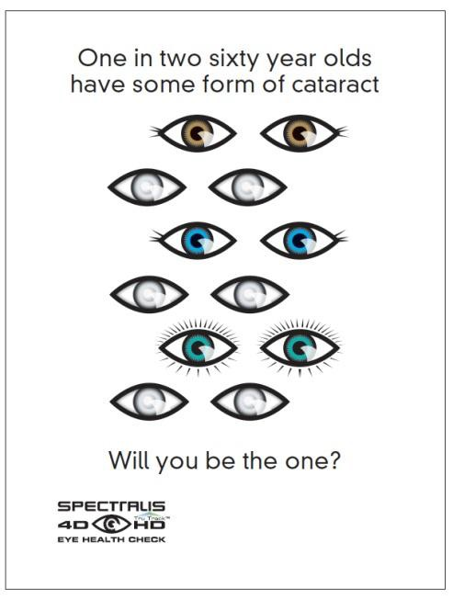
Don’t let vision loss take away your quality of life. Call us today on ADD YOUR TELEPHONE NUMBER HERE. Yours sincerely

Signature

