ADD YOUR ADDRESS HERE
94255-001 UK.BE14

ADD YOUR P ATIENT’S AD DRESS HERE

Date

Dear ADD YOU R PATIE N T’S NAME HERE ,

Your vision is a precious thing, and we at ADD YOUR NAME HERE are dedicated to protecting it, so that you can maintain a mobile, independent and enjoyable life.

We are contacting you, because our records show that you may be at a higher-than-average risk of developing diabetes due to your family history. Diabetes is a sight threatening condition that is on the increase in the UK and patient numbers are expected to reach 5 million by 2025. Globally one in two with diabetes don't even know they have the disease.

A comprehensive eye health check isn't just about a new pair of spectacles or contact lenses. It can reveal early changes in your eyes of which you may be unaware. Early detection allows for early treatment and a better outcome for you. With our new 4D HD imaging technology, we are now able to identify diabetes and monitor the smallest change, and that changes everything. The SPECTRALIS 4D HD Eye Health Check, uses a patented eye-tracking system that produces 3-dimensional images of the eye, allowing us to more easily identify if you are at risk of eye disease. The tracking system allows the scan to be placed in exactly the same place on every visit, giving a true 4D view of change over time.

Please contact us to schedule your SPECTRALIS 4D HD Eye Health Check. It is fast, non-contact and does not present you with a bright flash of light or a puff of air. You simply sit in front of the instrument and your eye is scanned in just a few seconds. Based on the information gathered in this exam, we will provide you with an individualised follow-up plan designed to help minimise the sight threatening risks of diabetes.

Don’t let vision loss take away your quality of life. Call us today on ADD YOUR TELEPHONE NUMBER HERE.

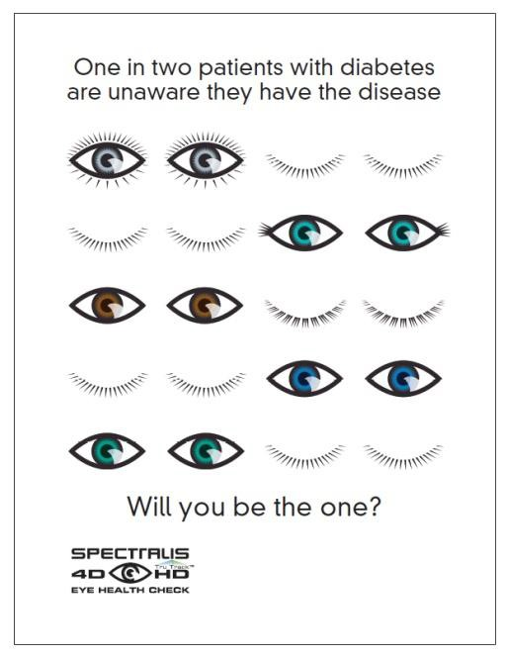
Yours sincerely

Signature

